|  |  |  |  |  |  |  |
| --- | --- | --- | --- | --- | --- | --- |
|  | | | | | | |
| **实验报告** | | | | | | |
|  | 课程名称 |  | **移动应用软件设计** |  | |  |
| 专业班级 |  | 信计182 |  | |
| 姓 名 |  | 张家政 |  | |
| 学 号 |  | 1181010050 |  | |
| 联系电话 |  |  |  | |
|  |  | | | |  | |
|  |  | | | |  | |

# 实验五 后台服务

## 一、实验目的

1. 掌握Service的生命周期及其用法
2. 了解MediaPlayer音乐播放控件的使用方法
3. 使用Service实现音乐播放器
4. 掌握绑定方式启动服务的方法

## 二、实验要求

1. 运用Service编写一个音乐播放器程序，实现音乐播放、暂停、停止等控制，程序运行效果如下图所示：

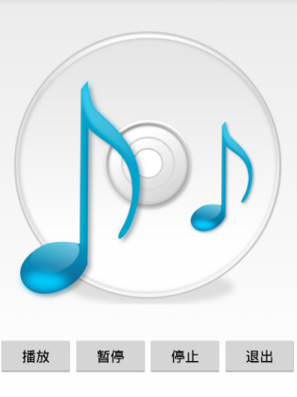

## 三、实验步骤

### **效果：**

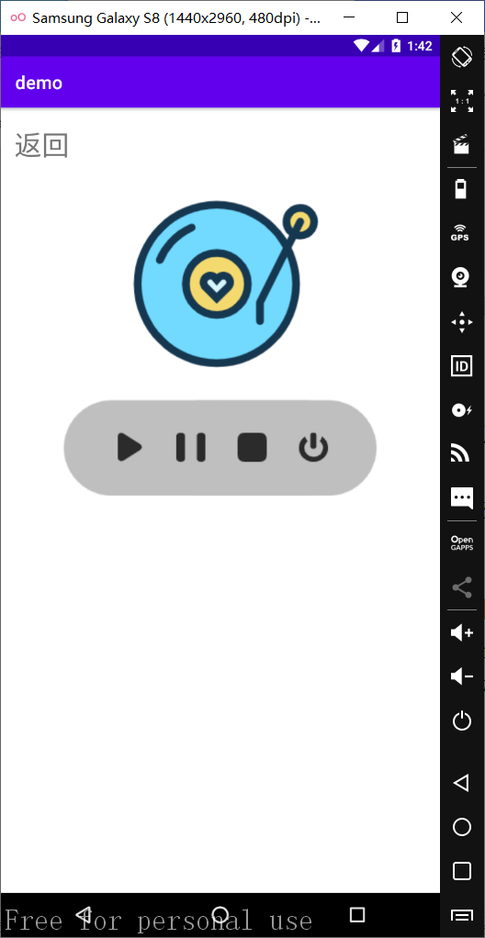

### Layout代码：

<**RelativeLayout  
 android:id="@+id/relative_showpower"  
 xmlns:android="http://schemas.android.com/apk/res/android"  
 android:layout_width="match_parent"  
 android:layout_height="match_parent"  
 android:layout_marginTop="20dp"  
 android:layout_marginBottom="40dp"**>  
 <**TextView  
 android:id="@+id/back4_btn"  
 android:layout_width="wrap_content"  
 android:layout_height="wrap_content"  
 android:text="返回"  
 android:layout_marginLeft="15dp"  
 android:textSize="30dp"  
 android:clickable="true"  
 android:onClick="back"**/>  
 <**ImageView  
 android:id="@+id/img_music"  
 android:layout_width="wrap_content"  
 android:layout_height="wrap_content"  
 android:layout_below="@id/back4_btn"  
 android:background="@drawable/music"  
 android:layout_centerHorizontal="true"**/>  
 <**LinearLayout  
 android:layout_width="wrap_content"  
 android:layout_height="wrap_content"  
 android:layout_below="@id/img_music"  
 android:layout_centerHorizontal="true"  
 android:background="@drawable/playerbackground"  
 android:orientation="horizontal"**>  
 <**ImageButton  
 android:id="@+id/btn_music_play"  
 android:layout_width="wrap_content"  
 android:layout_height="wrap_content"  
 android:background="@drawable/play"  
 android:layout_gravity="center_vertical"  
 android:layout_marginLeft="60dp"  
 android:onClick="playMusic"**/>  
 <**ImageButton  
 android:id="@+id/btn_music_pause"  
 android:layout_width="wrap_content"  
 android:layout_height="wrap_content"  
 android:background="@drawable/pause"  
 android:layout_gravity="center_vertical"  
 android:layout_marginLeft="35dp"  
 android:onClick="pauseMusic"**/>  
 <**ImageButton  
 android:id="@+id/btn_music_stop"  
 android:layout_width="wrap_content"  
 android:layout_height="wrap_content"  
 android:background="@drawable/stop"  
 android:layout_gravity="center_vertical"  
 android:layout_marginLeft="35dp"  
 android:onClick="stopMusic"**/>  
 <**ImageButton  
 android:id="@+id/btn_music_exit"  
 android:layout_width="wrap_content"  
 android:layout_height="wrap_content"  
 android:background="@drawable/exit"  
 android:layout_gravity="center_vertical"  
 android:layout_marginLeft="35dp"  
 android:onClick="exitMusic"**/>  
 </**LinearLayout**>  
</**RelativeLayout**>

### 逻辑代码：

**public class** MusicPlayerActivity **extends** AppCompatActivity {  
 **private** TextView **back**;  
 **private** MediaPlayer **mediaPlayer**;  
 @Override  
 **protected void** onCreate(Bundle savedInstanceState) {  
 **super**.onCreate(savedInstanceState);  
 setContentView(R.layout.***musicplayer_layout***);  
 }  
 **public void** playMusic(View v) {  
 **if** (**mediaPlayer**==**null**)  
 **mediaPlayer** = MediaPlayer.*create*(**this**, R.raw.***music***);  
 **mediaPlayer**.start();  
 }  
 **public void** pauseMusic(View v) {  
 **if** (**mediaPlayer** != **null** && **mediaPlayer**.isPlaying()) {  
 **mediaPlayer**.pause();  
 }  
 }  
 **public void** stopMusic(View v) {  
 **if** (**mediaPlayer** != **null**) {  
 **mediaPlayer**.stop(); *//停⽌* **mediaPlayer**.reset(); *//重置* **mediaPlayer**.release(); *//释放资源* **mediaPlayer** = **null**; *//重新赋值为空* }  
 }  
 **public void** exitMusic(View view) {  
 stopMusic(view);  
 finish();  
 }  
 **public void** back(View v) {  
 Intent intent = **new** Intent(**this**, HomeActivity.**class**);  
 startActivity(intent);  
 }  
}

### Service代码：

**public class** PlayerService **extends** Service {  
 **private** MediaPlayer **mediaPlayer**;  
 **public** IBinder onBind(Intent intent){  
 **return null**;  
 }  
 **public int** onStartCommand(Intent intent, **int** flags, **int** startId){  
 String action = intent.getStringExtra(**"action"**);  
 **switch** (action) {  
 **case "play"**:  
 playMusic();  
 **break**;  
 **case "stop"**:  
 stopMusic();  
 **break**;  
 **case "pause"**:  
 pauseMusic();  
 **break**;  
 }  
 **return super**.onStartCommand(intent, flags, startId);  
 }  
 **private void** playMusic() {  
 **if** (**mediaPlayer** == **null**)  
 *//调⽤MediaPlayer的静态⽅法create* **mediaPlayer** = MediaPlayer.*create*(**this**, R.raw.***music***);  
 **mediaPlayer**.start();  
 }  
 **private void** stopMusic() {  
 **if** (**mediaPlayer** != **null**) {  
 **mediaPlayer**.stop(); *//停⽌* **mediaPlayer**.reset(); *//重置* **mediaPlayer**.release(); *//释放资源* **mediaPlayer** = **null**; *//重新赋值为空* }  
 }  
 **private void** pauseMusic() {  
 **if** (**mediaPlayer** != **null** && **mediaPlayer**.isPlaying()) {  
 **mediaPlayer**.pause();  
 }  
 }  
 @Override  
 **public void** onDestroy() {  
 stopMusic();  
 **super**.onDestroy();  
 }  
}

1. **实验报告要求**
2. 严格按照实验报告格式完成实验报告并上交
3. 按照步骤对实验过程进行截图和分析（包括核心源代码、文字说明）